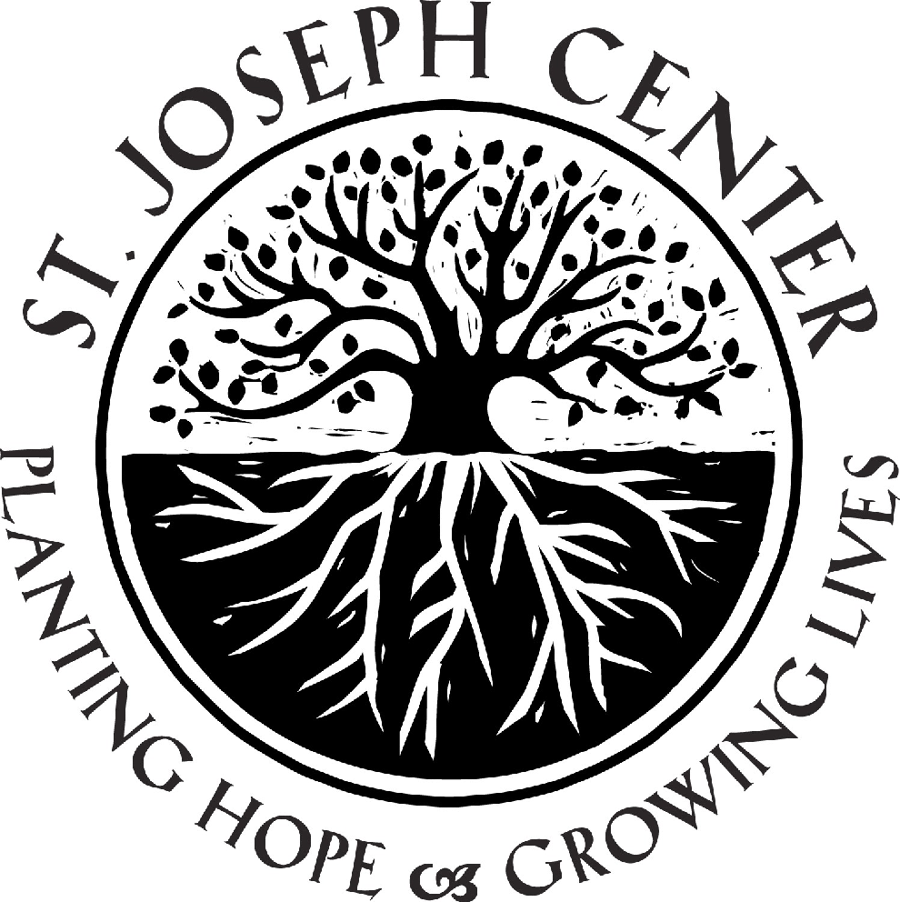

Navigator
Homeless Service Center Program

St. Joseph Center’s mission is to provide working poor families, as well as homeless men, women and children of all ages with the inner resources and tools to become productive, stable and self-supporting members of the community. We save lives every day by helping vulnerable people make progress toward stability and self-sufficiency. Since our founding in 1976 by two Sisters of St. Joseph of Carondelet we have grown into a multifaceted social service organization that provides hope through empowerment to more than 6,000 low-income and homeless individuals annually on Los Angeles’s Westside and in South LA. Our services encompass outreach and engagement, housing, mental health, and education. The programs we offer are strategically integrated, target a broad range of client populations, and are founded upon intensive, individualized care. Respect for the dignity of each person is the cornerstone of St. Joseph Center’s approach. Staff and volunteers make every effort to provide a welcoming, safe place where all people are treated with compassion.

Under the supervision of the HSC Program Manager, the Navigator will provide outreach, assessment and care coordination to homeless community members living on the street.

Responsibilities include:

- Provide street outreach and engagement services to homeless community members living outside and/or frequenting St. Joseph Center’s Homeless Service Center.

- Work in a culturally competent and empathetic manner that allows you to quickly develop trust and rapport with marginalized populations.

- Identify fragile, at-risk people in need of homeless services and/or prevention services

- In conjunction with clients, assess/triage them to develop a service plan. Provide linkage to identified resources including shelter and/or transitional and permanent housing, government benefits, money management, medical and mental health treatment, substance abuse services other social services.

- Assist homeless individuals in the development of a plan leading to a more permanent and stable environment through a phased strategy of consistent street outreach and engagement.

- Link the client to ongoing case management once housed to ensure they maintain their housing.

- Enter all client demographic information, track services and activities in a database.

- Write case notes confirming services provided and outcomes achieved based on documentation provided by client and maintained in file.

Qualifications/Skills Preferred:

- B.A. degree in related field and/or one year’s experience in street outreach or case management.
- Knowledge of and/or experience with homeless issues a plus.
- A passion and dedication to the mission of serving homeless and low-income people in a way that promotes self-sufficiency is required.
- Ability to be a team player and collaborator
- Proficiency in Microsoft Word, Excel and Outlook
- Detail oriented and a self-starter willing to take direction
- Excellent communication and written skills with an ability to connect with under-served populations in a way that promotes dignity

